

Object Oriented Software Engineering
DRBSE2401

Group Members :
- Yonas Addisu--------------------------------------------------VQ2051
- Saron Demile--------------------------------------------------FX3708
- Kaleb Getnet---------------------------------------------------AQ7592

Submitted to : Mr. Seyum
Submission Date: 5/3/26

Table of Contents
Acknowledgment 4
Abstract 5
CHAPTER ONE 7
INTRODUCTION 7
1.1 Background of the Study 7
1.2 Statement of the Problem 7
1.3 Objectives of the Study 8
1.3.1 General Objective 8
1.3.2 Specific Objectives 8
1.4 Scope of the Study 9
1.6 Significance of the Study 10
1.7 Methodology 10
1.8 Organization of the Document 11
CHAPTER TWO 11
EXISTING SYSTEM ANALYSIS AND PROPOSED SYSTEM 11
2.1 Introduction 11
2.2 Existing System Analysis 11
2.3 Problems in the Existing System 12
2.4 Proposed System 13
2.5 Benefits of the Proposed System 13
2.6 Requirement Gathering Method 14
CHAPTER THREE 14
SYSTEM REQUIREMENTS 14
3.1 Introduction 14
3.2 Functional Requirements 15
3.3 Non-Functional Requirements 15
3.4 User Roles 16
CHAPTER FOUR 16
SYSTEM MODELS 16
4.1 Introduction 16
4.2 Use Case Diagram 17
4.3 Data Flow Diagrams (DFD) 17
4.3.1 Context Diagram 18
4.3.2 Level 0 Data Flow Diagram 18
4.3.3 Level 1 Data Flow Diagram 20
4.4 Data Model 20
21
4.4.1 Entity Description 21
4.4.2 Relationships and Cardinality 22
4.4.3 Attributes Description 22
CHAPTER 5 23
USER INTERFACE DESIGN 23
5.1 Introduction 23
5.2 General Design Considerations 23
5.3 Input Design 23
5.3.1 Patron Registration Form 23
5.4 Output Design 25
5.4.1 Seat Availability Report 25
5.4.2 Ticket Sales Report 25
5.4.3 Patron Ticket Report 26
5.5 Summary 26
CHAPTER 6 26
CONCLUSION AND LESSONS LEARNED 26
6.1 Conclusion 26
6.2 Lessons Learned 27
6.3 Future Improvement 27

Acknowledgment
We would like to thank our teacher for giving us this assignment and for the guidance provided during the course. The explanations given in class helped us understand how to approach the project in a better way.
This assignment gave us a nice opportunity to improve our teamwork and apply what we learned in systems analysis and design to a practical case study.

Abstract
The Medallion Theatre currently uses a manual system to manage ticket reservations and sales. This method creates different problems such as lost reservations, double booking of seats, slow customer service, and difficulty in preparing reports. Because of these issues, the theatre needs a computerized system that can improve accuracy and efficiency.
The main purpose of this project is to analyze and design a ticket sales management system for the Medallion Theatre. The proposed system will help manage patron information, theatre productions, performances, seat availability, and ticket transactions in an organized database system.
The system will allow staff members to register customers, schedule performances, reserve or sell seats, and generate reports about sold and available tickets. It will also reduce manual errors and improve service quality for customers.
This project applies systems analysis and design concepts to solve a real-world business problem. The final result is expected to provide a reliable, user-friendly, and efficient solution for managing theatre ticket operations.

CHAPTER ONE

INTRODUCTION

1.1 Background of the Study
Technology has become an important parts of modern business operations. Many organizations are replacing manual systems with computerized systems to improve efficiency, accuracy, and service quality. Ticket management systems are widely used by cinemas, theatres, concert halls, and other entertainment organizations to manage reservations, customer information, seat allocation, and ticket sales.
The Medallion Theatre currently uses a manual process to manage ticket reservations and sales. Customer reservations are recorded manually, which creates problems such as missing reservations, double bookking of seats, delays in customer service, and difficulties in tracking available seats. These problems reduce operational efficiency and may negatively affect customer satisfaction.
To solve these issues, there is a need for a computerized ticket sales management system that can organize theatre operations in a more reliable and efficient manner. The proposed system will help manage patrons, productions, performances, seating arrangements, and ticket transactions through a centralized database system.
This project focuses on analyzing and designing a system that can improve the current ticket reservation process of the Medallion Theatre and reduce the limitations of the manual system.

1.2 Statement of the Problem
The Medallion Theatre currently manages ticket reservations and sales using a manual system. Although this approach has been used for many years, it has created several operational problems that affect both the theatre staff and customers.
One of the major problems in the current system is the loss or misplacement of customer reservations. Since reservations are written manually and transferred between records, there is a high chance of human error. This may result in reserved seats being sold to another customer, causing inconvenience and dissatisfaction.
Another problem is the difficulty in tracking seat availability for different performances. Staff members must manually check seating records, which is time-consuming and increases the possibility of mistakes such as double booking or incorrect seat allocation.
The current system also makes report generation difficult. Preparing information about sold tickets, available seats, or customer purchase history requires manual checking of records, which consumes time and may produce inaccurate results.
In addition, maintaining customer information manually makes it difficult for the theatre to identify frequent patrons or communicate upcoming events effectively.
Because of these problems, the theatre requires a computerized ticket sales management system that can improve accuracy, reduce manual work, increase efficiency, and provide better customer service.

1.3 Objectives of the Study

1.3.1 General Objective
The general objective of this project is to analyze and design a computerized ticket sales management system for the Medallion Theatre.

1.3.2 Specific Objectives
The specific objectives of the project are:
- To study the existing ticket reservation and sales process of the theatre
- To identify problems and limitations in the current manual system
- To design a system that manages patrons, productions, performances, and ticket sales
- To reduce errors related to seat reservation and ticket management
- To provide fast and accurate access to seat availability information
- To generate reports about sold and available tickets
- To improve efficiency and customer service within the theatre

1.4 Scope of the Study
This project focuses on the analysis and design of a ticket sales management system for the Medallion Theatre. The system is intended to manage major theatre operations related to customer registration, production management, performance scheduling, seat allocation, and ticket sales.
The proposed system will allow theatre staff to:
- Register and manage patron information
- Add and manage theatre productions
- Schedule performances for different dates and times
- Reserve and sell tickets for specific seats
- View available and sold seats for performances
- Generate reports related to ticket sales and customer purchases
The study mainly focuses on the internal operations of the theatre ticket office and does not include advanced online payment systems, mobile applications, or external financial integrations.
1.5 Limitations of the Study
This project is mainly focused on the analysis and design of a ticket sales management system for the Medallion Theatre. Due to time and resource limitations, some advanced features and functionalities are not included in the scope of the study.
The proposed system is designed primarily for use within the theatre ticket office and does not fully support online ticket purchasing through the internet. Features such as online payment gateways, mobile applications, and integration with external banking systems are beyond the scope of this project.
In addition, the study is based on the information provided in the case study and assumptions made during system analysis. Therefore, some real-world operational details of large theatre organizations may not be fully represented.
Another limitation is that the project focuses mainly on system analysis and design activities rather than full-scale implementation and deployment in a real production environment.

1.6 Significance of the Study
This project is important because it provides a solution to the operational problems currently faced by the Medallion Theatre in managing ticket reservations and sales manually.
The proposed system will help the theatre improve efficiency by automating major activities such as customer registration, seat allocation, ticket sales, and report generation. It will also reduce human errors related to lost reservations and double booking of seats.
The study is also beneficial for theatre staff because it simplifies daily operations and improves access to information regarding performances and seat availability.
Customers will also benefit from the system through faster service, improved reservation accuracy, and better management of ticket purchases.
From an academic perspective, this project helps apply systems analysis and design concepts to a real-world business problem. It also improves understanding of requirement analysis, process modeling, database design, and system planning.

1.7 Methodology
To complete this project, different methods of information gathering and system analysis were used. The study mainly relies on the case study description provided for the Medallion Theatre ticket sales process.
Information about the current system was collected and analyzed to identify existing problems, user requirements, and system limitations. The gathered information was then used to design a proposed computerized solution.
Different systems analysis and design techniques were applied during the project, including:
- Requirement analysis
- Process modeling
- Data modeling
- Use case analysis
- User interface design
Tools such as Data Flow Diagrams (DFD), Use Case Diagrams, and Entity Relationship Diagrams (ERD) were used to represent the structure and behavior of the proposed system.

1.8 Organization of the Document
This document is organized into different chapters.
Chapter One presents the introduction of the study, including the background, problem statement, objectives, scope, limitations, significance, and methodology of the project.
Chapter Two discusses the analysis of the existing system and describes the proposed system.
Chapter Three presents the functional and nonfunctional requirements of the system.
Chapter Four contains the system models and design diagrams such as use case diagrams, data flow diagrams, and entity relationship diagrams.
Chapter Five discusses feasibility analysis and implementation considerations.
Finally, Chapter Six presents the conclusion and recommendations of the study.

CHAPTER TWO

EXISTING SYSTEM ANALYSIS AND PROPOSED SYSTEM

2.1 Introduction
This chapter focuses on analyzing the current ticket reservation and sales process used by the Medallion Theatre. The existing system is examined in order to understand how activities are currently performed and to identify the major problems faced by the theatre staff and customers. Based on the findings from the analysis, a proposed computerized system is introduced to improve the overall operation of the theatre.
The chapter mainly discusses the current manual system, the limitations found in the system, and the improvements expected from the proposed solution.

2.2 Existing System Analysis
The Medallion Theatre currently manages its ticket reservation and sales activities manually. Customers reserve tickets either by calling the theatre or by visiting the ticket office in person. After receiving the reservation request, theatre staff record customer details and seat information manually on paper records and seating charts.
Information about productions, performances, available seats, and ticket sales is also maintained manually. Staff members need to check seating charts physically before confirming whether a seat is available for a particular performance. Once the reservation is confirmed, the information is recorded manually again.
The current process depends heavily on human effort, which makes the system slow and difficult to manage as the number of customers and performances increases. Since records are stored manually, searching and updating information also requires additional time and effort.
Another issue with the existing system is the lack of proper coordination between reservation records and seating information. In some cases, reservations may not be transferred correctly to the main seating chart, which can result in customers losing their reserved seats.

2.3 Problems in the Existing System
The current manual system has several problems that affect the daily operation of the theatre.
One of the major problems is the loss or misplacement of reservation records. Since ticket reservations are handled manually, there is a high possibility of human error during recording or transferring information. This may cause reserved seats to be sold to another customer.
The system also makes seat management difficult. Staff members must check seating charts manually to determine which seats are available for each performance. As a result, mistakes such as double booking of seats may occur.
Another problem is the amount of time required to perform simple activities. Searching customer information, checking reservations, and preparing reports all require manual work, which slows down customer service.
The existing system also lacks efficient reporting capabilities. Preparing reports about ticket sales or available seats requires checking multiple records manually, which may lead to inaccurate information.
In addition, storing customer information manually makes it difficult for the theatre to identify regular patrons or maintain organized customer records.

2.4 Proposed System
To solve the problems found in the current system, a computerized ticket sales management system is proposed for the Medallion Theatre. The proposed system is designed to automate the major activities related to ticket reservation and sales.
The system will store information about patrons, productions, performances, seats, and ticket transactions in a centralized database. Theatre staff will be able to access and manage information more efficiently through a user-friendly interface.
With the proposed system, staff members can quickly check seat availability, register customers, reserve tickets, and generate reports without relying on manual records. The system will also help prevent problems such as double booking and missing reservations by maintaining accurate and organized data.
The proposed system is expected to improve the efficiency of theatre operations, reduce human error, and provide better service for customers.

2.5 Benefits of the Proposed System
The proposed computerized system will provide several improvements compared to the current manual process used by the theatre.
One important benefit of the system is improved accuracy in ticket management. Since reservation information will be stored electronically, the chances of losing records or assigning the same seat to multiple customers will be reduced.
The system will also improve the speed of operations within the ticket office. Staff members will be able to search customer information, performance schedules, and seat availability much faster than before.
Another advantage of the proposed system is better data organization. Information related to customers, performances, and ticket sales will be stored in a structured database, making it easier to access and update records whenever necessary.
The system will also simplify report generation. Reports related to sold tickets, available seats, and customer purchases can be generated directly from the database system, reducing manual work and improving accuracy.
Overall, the proposed system is expected to improve operational efficiency, reduce errors, and increase customer satisfaction.

2.6 Requirement Gathering Method
Different methods were used to understand the current system and identify the requirements of the proposed system.
The main source of information for this project was the case study description provided for the Medallion Theatre. The case study explained how the current reservation process works and described the problems faced by the theatre staff and customers.
Observation was also used as a system analysis technique by studying the flow of activities described in the case study. Existing records and reservation procedures were analyzed to understand how information is currently managed.
In addition, information gathered from the conversation between Dr. Waggoner and the theatre staff helped identify the major limitations of the current system and the improvements needed in the proposed solution.

CHAPTER THREE

SYSTEM REQUIREMENTS

3.1 Introduction
This chapter presents the requirements of the proposed ticket sales management system for the Medallion Theatre. The requirements describe what the system is expected to do and how it should perform when it is implemented.
The main purpose of this chapter is to clearly define the services provided by the system and the conditions under which the system will operate. These requirements are based on the problems identified in the existing system and the needs of the theatre staff and customers.
The requirements are divided into functional requirements, which describe the main operations of the system, and non-functional requirements, which describe the quality and performance of the system.

3.2 Functional Requirements
The functional requirements describe the main activities that the system must support. These requirements are derived from the current processes of the Medallion Theatre and are intended to improve the way ticket reservations and sales are handled.
The system should allow theatre staff to register and manage patron information. When a customer makes a reservation, their personal details such as name, address, phone number, and email should be recorded in the system. The system should also allow existing patron information to be searched and updated when necessary.
The system should provide a way to manage theatre productions and performances. Staff members should be able to add new productions, define their type, and schedule multiple performances for each production. Each performance should include information such as date and whether it is a matinee or evening show.
Another important function of the system is seat management. The system should maintain a record of all seats available in the theatre and their categories. It should allow staff members to view seat availability for a specific performance and select seats for reservation or sale.
The system should support ticket reservation and sales. Staff members should be able to reserve seats for customers and confirm ticket purchases. The system should ensure that the same seat cannot be assigned to more than one customer for the same performance.
The system should also provide reporting functionality. Staff members should be able to generate reports showing the number of tickets sold and available for a specific performance. In addition, the system should allow searching for tickets purchased by a particular patron.

3.3 Non-Functional Requirements
The non-functional requirements describe the quality attributes of the system and how it should perform.
The system should be easy to use so that theatre staff can operate it without difficulty. The user interface should be simple and clear, allowing users to perform tasks such as searching for patrons, selecting seats, and processing ticket sales efficiently.
The system should be reliable and minimize errors during operation. It should prevent problems such as double booking of seats and loss of reservation information.
Performance is also an important requirement. The system should respond quickly when retrieving information, such as checking seat availability or searching for customer records.
The system should ensure the security of data. Access to the system should be restricted to authorized staff members, and customer information should be stored securely.
The system should also be maintainable so that future updates or modifications can be made easily when new requirements arise.

3.4 User Roles
The system will be used by different individuals within the theatre, each with specific responsibilities.
The ticket clerk is responsible for handling customer interactions. This includes registering patrons, checking seat availability, reserving tickets, and processing ticket sales.
The box office manager has a supervisory role. The manager is responsible for overseeing ticket operations, managing performances, and reviewing reports related to ticket sales and seat availability.
Patrons are also indirectly involved in the system. Although they do not interact with the system directly, their information is recorded and managed by the theatre staff during the reservation and ticket purchasing process.

CHAPTER FOUR

SYSTEM MODELS

4.1 Introduction
This chapter presents the system models used to represent the structure and behavior of the proposed ticket sales management system. These models help in understanding how different parts of the system interact and how information flows within the system.
The models are developed based on the requirements identified in the previous chapter. They provide a visual representation of the system, making it easier to analyze and design before implementation.

4.2 Use Case Diagram
The Use Case Diagram shows how different users interact with the system. It identifies the main actors involved and the functions they perform.
In the Medallion Theatre system, the main actors are the ticket clerk and the box office manager. The system allows these users to perform activities such as registering patrons, managing performances, reserving tickets, and generating reports. 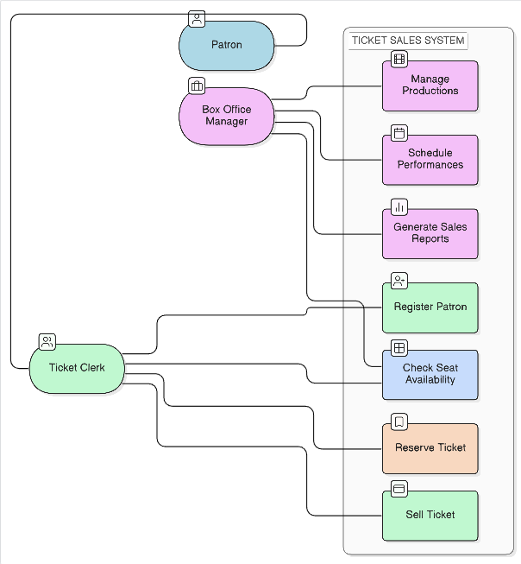

4.3 Data Flow Diagrams (DFD)
Data Flow Diagrams are used to show how data moves within the system. Unlike the Use Case Diagram, which focuses on user interaction, the DFD focuses on how information is processed, stored, and transferred between different parts of the system.
In the Medallion Theatre Ticket Sales System, data flows between users, processes, and data stores such as patron records, performance details, and ticket information. The diagrams help to clearly represent how ticket reservations are handled and how information is updated in the system.
To provide a clear understanding, the system is represented using three levels of Data Flow Diagrams: the Context Diagram, Level 0 Diagram, and Level 1 Diagram.

4.3.1 Context Diagram
The Context Diagram represents the entire system as a single process and shows its interaction with external entities. It provides a high-level view of the system without showing internal details.
In this system, the main external entities are the ticket clerk and the patron. The ticket clerk interacts with the system by entering customer information, reserving tickets, and processing sales. The patron provides request information and receives ticket details.
The Context Diagram helps define the system boundary and shows how data flows between the system and its users.
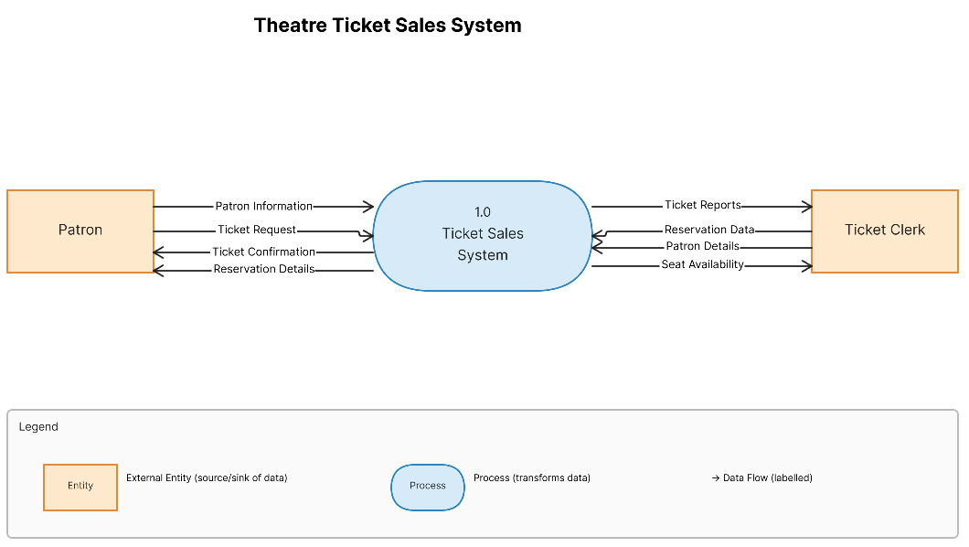

4.3.2 Level 0 Data Flow Diagram
The Level 0 Data Flow Diagram provides a more detailed representation of the system by breaking it into its main processes. It shows how data flows between these processes and the data stores.
The main processes in the system include managing patron information, handling performance data, processing ticket reservations and sales, and generating reports. These processes interact with data stores such as patron data, performance data, and ticket data.
This diagram gives a clearer picture of how the system operates internally and how different components are connected.
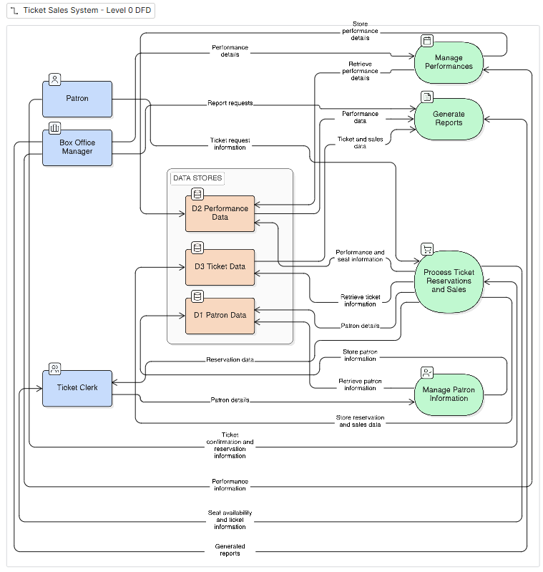

4.3.3 Level 1 Data Flow Diagram
The Level 1 Data Flow Diagram expands one of the main processes from the Level 0 diagram. In this case, the ticket reservation and sales process is described in more detail.
The diagram shows steps such as checking seat availability, selecting seats, recording ticket information, and updating the system. It also shows how data flows between these steps and the system’s data stores.
This level of detail helps in understanding how the system prevents issues such as double booking and missing reservations.
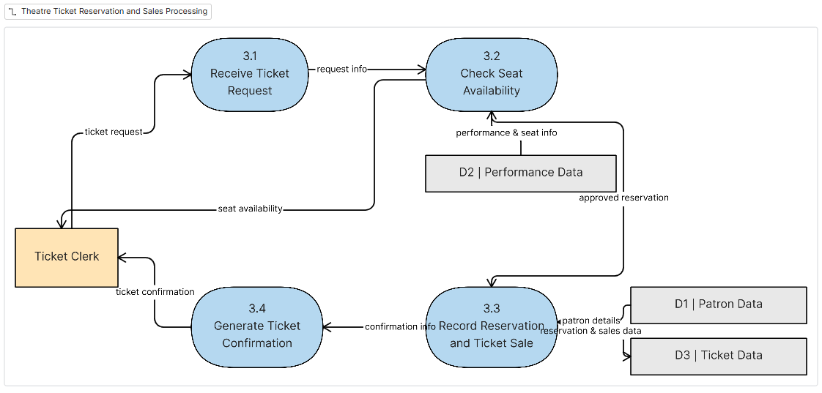

4.4 Data Model
The data model describes how data is structured and organized within the system. It identifies the main entities involved in the ticket sales system and shows the relationships between them.
In the Medallion Theatre Ticket Sales System, the main entities include patrons, productions, performances, seats, and tickets. These entities store the essential information required to manage ticket reservations and sales effectively.
The data model is represented using an Entity-Relationship Diagram (ERD), which provides a clear visual representation of how data is connected within the system.

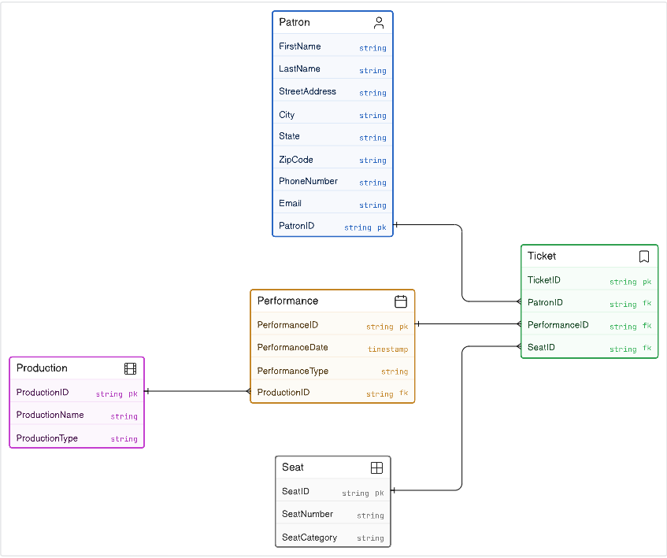

4.4.1 Entity Description
The main entities in the system are described below:
Patron : This entity stores information about customers who purchase or reserve tickets. It includes details such as patron ID, name, contact information, and address.
Production : This entity represents the shows or events held at the theatre. It includes information such as production name and type.
Performance : This entity represents specific showings of a production. It includes the performance date and whether it is a matinee or evening show.
Seat : This entity represents individual seats in the theatre. Each seat has a unique seat number and belongs to a specific seating category.
Ticket : This entity represents a reservation or purchase made by a patron. It links a patron, a performance, and a specific seat.

4.4.2 Relationships and Cardinality
The relationships between the entities define how data is connected within the system. Each relationship also specifies the cardinality, which indicates how many instances of one entity are associated with another.
A production can have multiple performances, but each performance belongs to only one production. This represents a one-to-many relationship between Production and Performance.
Each performance can have many tickets associated with it, while each ticket corresponds to only one performance. This forms a one-to-many relationship between Performance and Ticket.
A patron can reserve or purchase multiple tickets, but each ticket is linked to a single patron. Therefore, there is a one-to-many relationship between Patron and Ticket.
Each seat can be assigned to many tickets across different performances, but for a single performance, a seat can only be assigned to one ticket. This establishes a relationship between Seat and Ticket.
These relationships ensure that the system maintains consistency and prevents issues such as double booking or missing reservations.

4.4.3 Attributes Description
Each entity in the system contains specific attributes that store relevant information.
The Patron entity includes attributes such as PatronID, first name, last name, address, city, state, zip code, phone number, and email address.
The Production entity includes ProductionID, production name, and production type.
The Performance entity includes PerformanceID, performance date, and performance type (matinee or evening).
The Seat entity includes SeatID, seat number, and seating category.
The Ticket entity includes TicketID, seat number, performance ID, patron ID, and ticket status.
These attributes provide the necessary details required for managing ticket reservations, tracking performances, and maintaining accurate records within the system.

CHAPTER 5

USER INTERFACE DESIGN

5.1 Introduction
This chapter describes the user interface design of the proposed Medallion Theatre Ticket Sales System. The purpose of the user interface is to allow users to interact with the system easily and perform their tasks without confusion.
The system will mainly be used by the ticket clerk and the box office manager. Therefore, the interface is designed to be simple, clear, and easy to understand. It focuses on supporting common activities such as registering patrons, managing performances, reserving tickets, and viewing reports.

5.2 General Design Considerations
In designing the interface, attention was given to simplicity and consistency. All screens follow a similar layout so that users can quickly become familiar with the system.
Clear labels are used for all input fields to reduce errors during data entry. The system also provides basic feedback messages to inform users whether an operation has been completed successfully or if there is a problem.
The design avoids unnecessary complexity and focuses only on the functions required by the system.

5.3 Input Design
The input design defines how users enter data into the system. The following forms are required for the system.

5.3.1 Patron Registration Form
This form is used to record new patron information and update existing records. It includes fields for entering personal and contact details such as name, address, phone number, and email.
The form contains buttons that allow the user to save new records, update existing information, or clear the form.
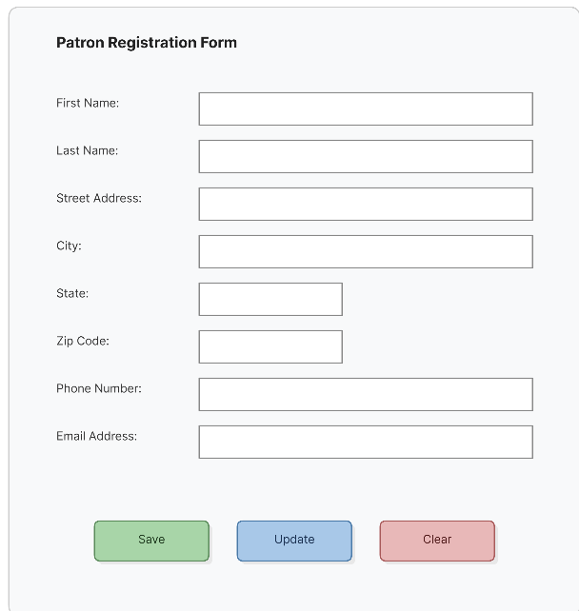
5.3.2 Performance Management Form
This form is used by the box office manager to manage performances. It allows the user to enter details such as the production name, performance date, and whether the performance is a matinee or evening show.
This ensures that all performance information is properly recorded before ticket reservations are made.
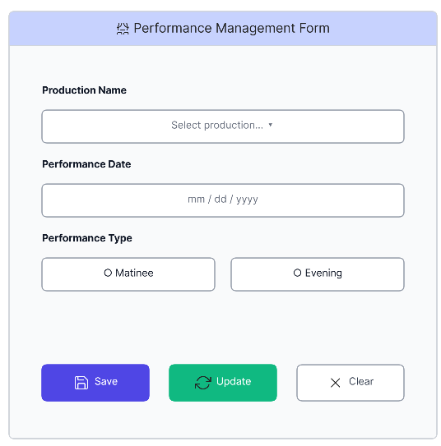
5.3.3 Ticket Reservation Form
This form is used by the ticket clerk to reserve or sell tickets. The user selects a patron and a performance, then chooses from the available seats.
The system should display available seats clearly to avoid double booking. Once the selection is made, the reservation is recorded and a confirmation is provided.
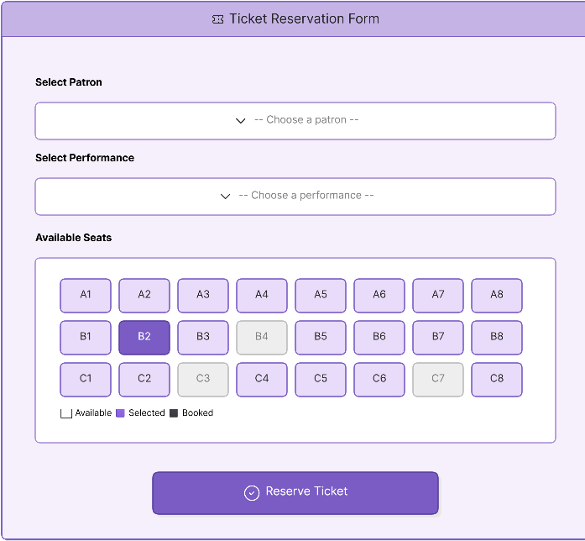

5.4 Output Design
The output design focuses on how information is presented to the user in the form of reports.

5.4.1 Seat Availability Report
This report shows the list of seats for a selected performance and indicates whether each seat is available or already reserved. It helps the ticket clerk quickly identify available seats.

5.4.2 Ticket Sales Report
This report provides information about the number of tickets sold for a particular performance. It helps the management understand how well a performance is doing.

5.4.3 Patron Ticket Report
This report displays the tickets purchased by a specific patron. It can be used to track customer activity and assist in resolving issues related to reservations.

5.5 Summary
This chapter presented the user interface design for the proposed system. The design focuses on simplicity and usability to ensure that users can perform their tasks efficiently.
The input forms and output reports were designed to support the main operations of the system, including managing patrons, handling ticket reservations, and generating useful information.

CHAPTER 6

CONCLUSION AND LESSONS LEARNED

6.1 Conclusion
This project focused on analyzing and designing a ticket sales system for the Medallion Theatre. The main objective was to improve the current manual system, which often leads to errors such as missing reservations and double booking of seats.
Through the analysis of the existing process, it became clear that a computerized system would help in organizing data more effectively and reducing human errors. The proposed system is designed to store information about patrons, productions, performances, seats, and ticket reservations in a structured way.
Different system modeling techniques were used to understand and design the system. Use case diagrams helped identify the interactions between users and the system, while data flow diagrams showed how information moves within the system. The entity-relationship diagram was used to define how data is stored and related.
Although the system has not been implemented, the design provides a clear foundation for future development. The proposed solution can improve efficiency, accuracy, and overall management of ticket sales at the theatre.

6.2 Lessons Learned
Working on this project provided a better understanding of the importance of system analysis and design before implementation. One of the key lessons learned is that identifying the requirements clearly at the beginning helps avoid confusion later in the development process.
Another important lesson is the value of proper data modeling. Designing a well-structured database makes it easier to manage information and prevents problems such as data inconsistency or duplication.
The project also showed the importance of visual modeling tools such as diagrams. Use case diagrams, data flow diagrams, and ER diagrams made it easier to understand the system from different perspectives.
In addition, the project highlighted how even small errors in manual systems can lead to major problems. By automating processes, organizations can improve accuracy and efficiency.

6.3 Future Improvement
In the future, the system can be extended to include additional features such as online ticket booking, integration with payment systems, and real-time seat availability display. These improvements can further enhance user convenience and system performance.

REFERENCES
- Fox, T. L. (n.d.). Medallion Theatre – Ticket Sales System Case Study. University of Mary Hardin-Baylor.
- Dennis, A., Wixom, B. H., & Roth, R. M. (2019). Systems Analysis and Design (7th ed.). John Wiley & Sons.
- Kendall, K. E., & Kendall, J. E. (2011). Systems Analysis and Design (8th ed.). Pearson.

